Htno:2403A51336

Batch:14

Assignment 4.3

**Task Description#1**

* Zero-shot: Prompt AI to write a function that checks whether a given year is a leap year.

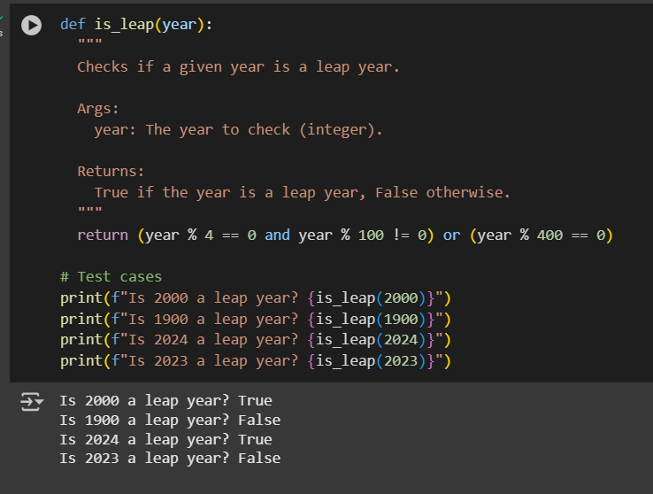

Output:



**Task Description#2**

* One-shot: Give one input-output example to guide AI in writing a function that converts centimeters to inches.

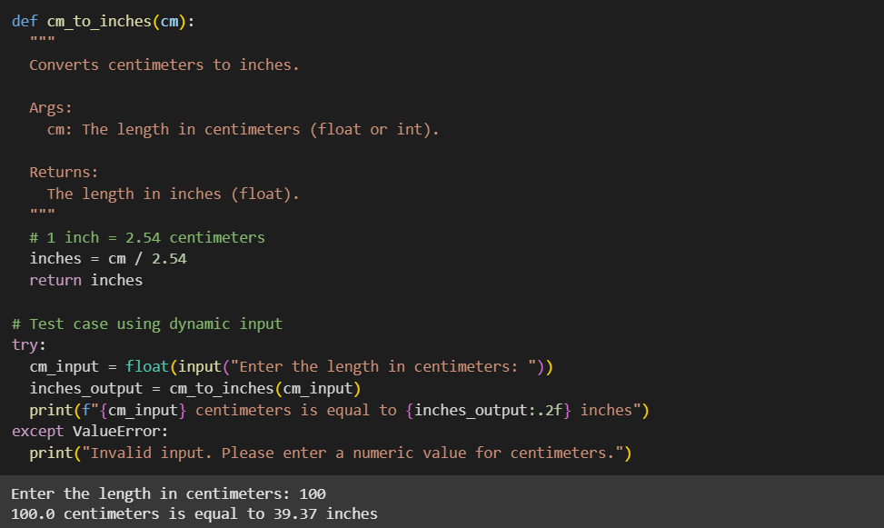

**Output:**



**Task Description#3**

* Few-shot: Provide 2–3 examples to generate a function that formats full names as “Last, First”.

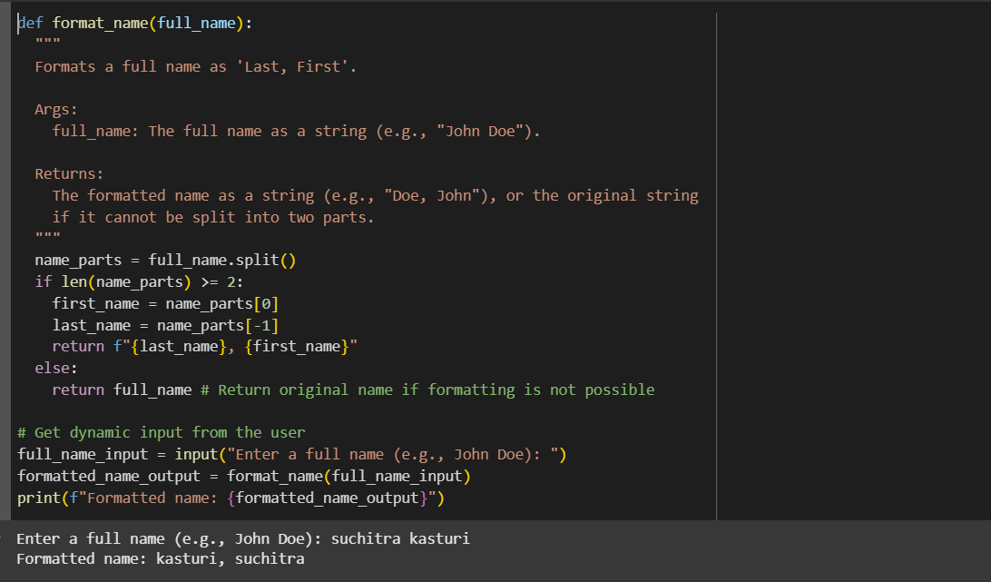

**Output:**



**Task Description#4**

* Compare zero-shot and few-shot prompts for writing a function that counts the number of vowels in a string.

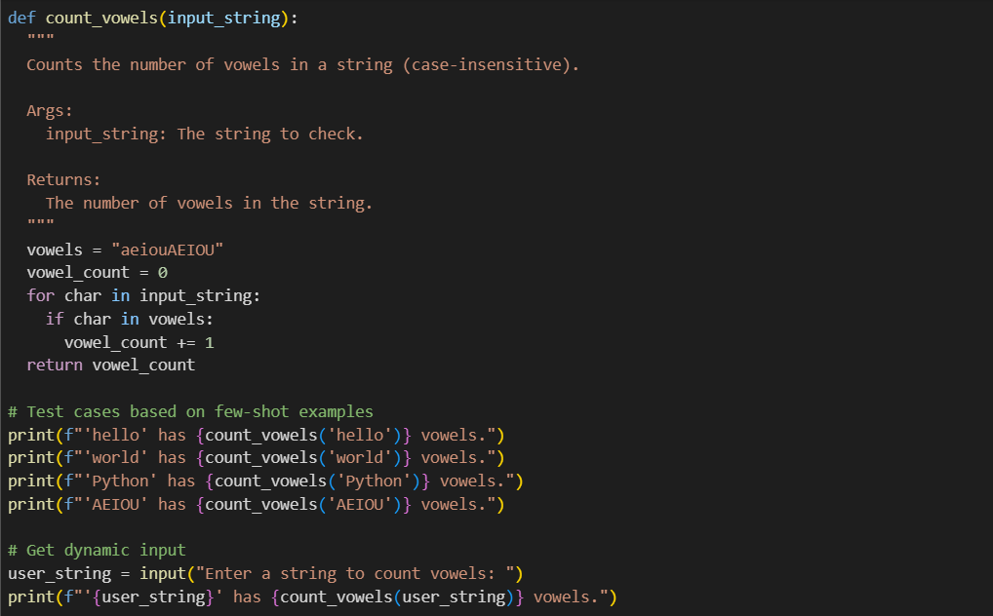

**Output:**

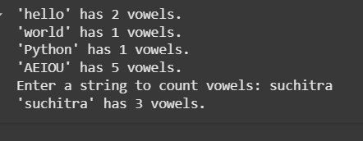

**Task Description#5**

Use few-shot prompting to generate a function that reads a .txt file and returns the number of lines.

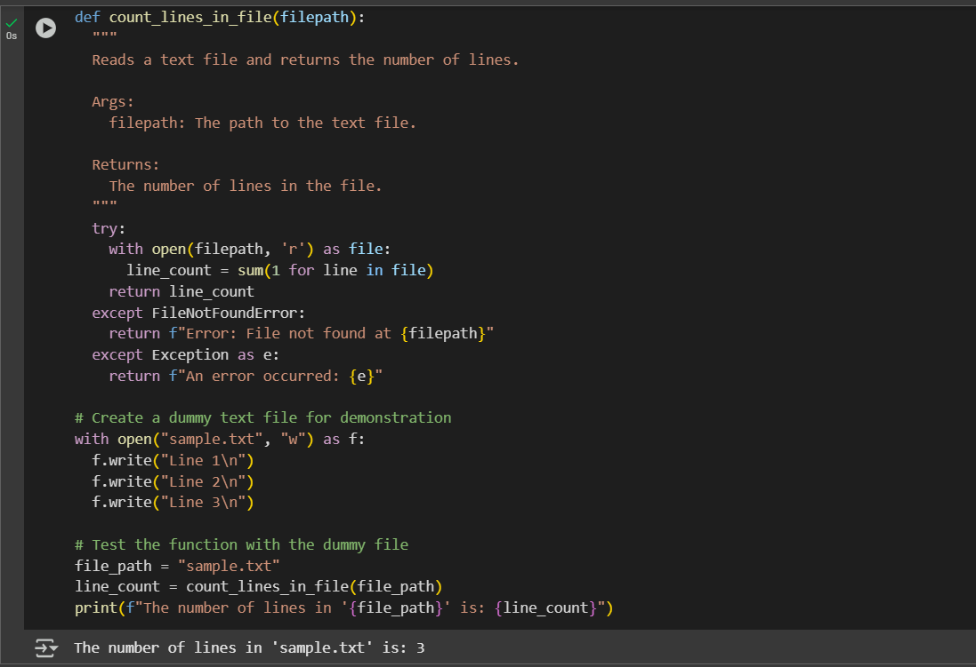

**Output:**

